Project Plan

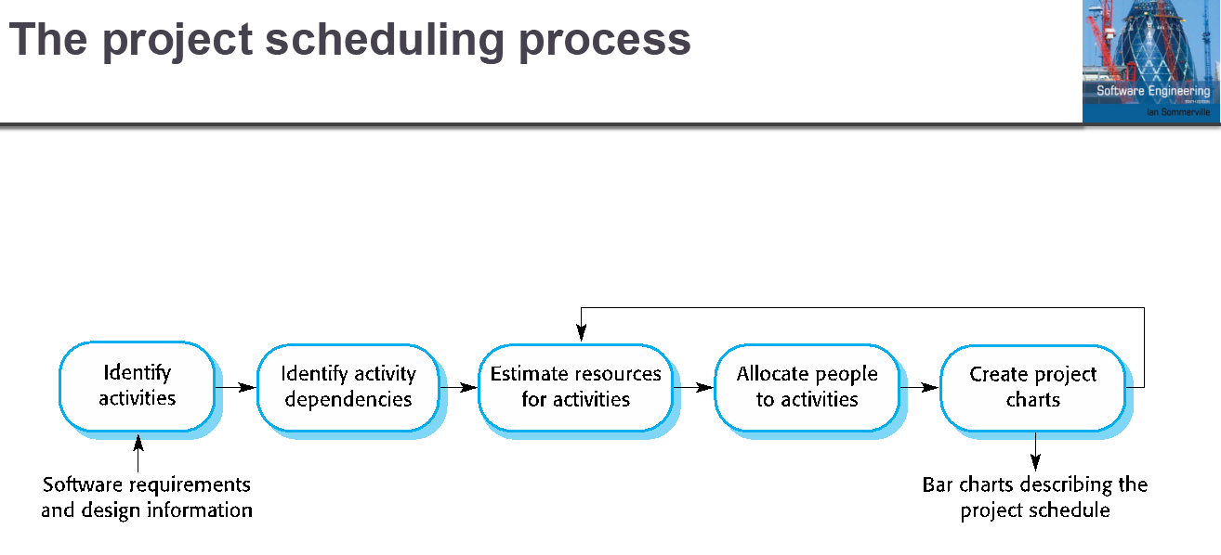
5 hours per person per week * 4 people * 8 weeks = 160 hours to work with
Tasks, durations, and dependencies
Task ID | Task | Effort in hours | Dependencies
T1
T2
T3
T4
T5
T6
T7

Allocation Table
Week | Michael | Joseph | Luke | James
1 | T | T | T | T
2 | T | T | T | T
3 | T | T | T | T
5 | T | T | T | T
6 | T | T | T | T
7 | T | T | T | T
8 | T | T | T | T

Allocation chart to be started

